Day-14

Task 1: What do you understand by Git Collaboration?
Git Collaboration is the process of multiple developers working together on the same project using Git. It allows team members to make changes independently, share their work, review code, and merge changes without overwriting each other's work.

Task 2: Why is collaboration necessary while working on Git?
Collaboration is necessary because software projects are usually developed by teams rather than a single person.
Advantages
- Enables multiple developers to work simultaneously.
- Prevents code overwriting.
- Makes tracking changes easy.
- Simplifies bug fixing.
- Supports code reviews before merging.
- Maintains complete version history.
- Makes project management easier.
- Allows rollback to previous versions if needed.

Task 3: What are the commands used while collaborating?
Command | Purpose
git clone <repository-url> | Copy remote repository to local machine
git branch | List branches
git checkout branch-name | Switch to another branch
git checkout -b branch-name | Create and switch to a new branch
git status | Show current status of files
git add . | Stage all changes
git commit -m "message" | Save staged changes locally
git pull origin main | Download latest changes from remote repository
git push origin branch-name | Upload local commits to remote repository
git fetch | Download latest updates without merging
git merge branch-name | Merge another branch into the current branch
git rebase main | Reapply commits on top of another branch
git log | Show commit history
git diff | Show differences between files/commits

Task 4: Typical Workflow while Working on Git
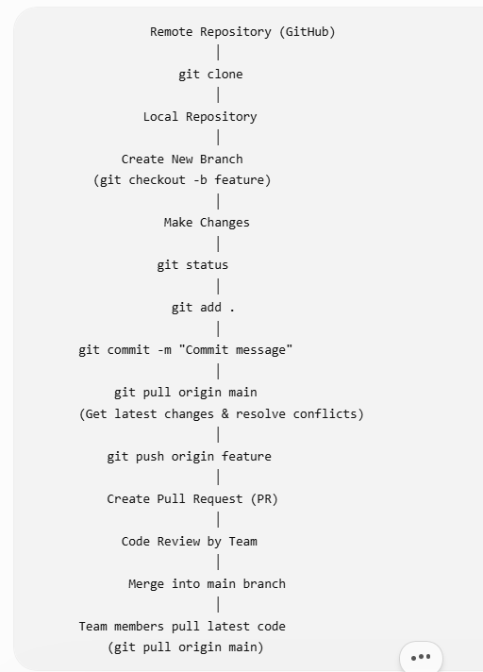

Task-5
Give some to do practices that we need to follow while working on Git Repo on a daily basis.
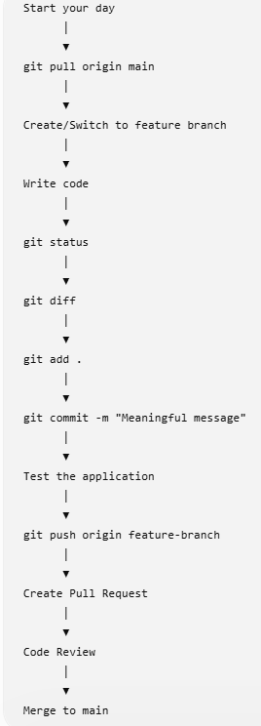

Task 6:
Create a demo typescript file and execute it

let message:string="hello all";
console.log(message);

Task 7:
Create an interface and try it out?
interface shaik {
name: string;
content: string;
email?: string;
}
const person: shaik = {
name: "Nagurvali",
content: "Learning TypeScript",
email:"shaik@gmail.com"
};
console.log(person);

Task 8:
In the above code use optional variable?
interface shaik {
name: string;
content: string;
email?: string;
}
const person: shaik = {
name: "Nagurvali",
content: "Learning TypeScript",
email:"shaik@gmail.com"
};
console.log(person);

Task 9:
Create a demo with constructor, default and with parameterised.

TypeScript does not support multiple constructors like Java or C++. Instead, you can use default parameter values to achieve similar behavior.
]

class Student {
id: number;
name: string;
constructor(id: number = 0, name: string = "Unknown") {
this.id = id;
this.name = name;
}
display(): void {
console.log("ID:", this.id);
console.log("Name:", this.name);
}
}
const s1 = new Student(); // Uses default values
const s2 = new Student(101, "Nagurvali"); // Uses provided values
s1.display();
s2.display();

Task 10;
What are primitive and special data types in typescript?

Primitive Data Types | Special Data Types
number | any
string | unknown
boolean | void
bigint | null
symbol | undefined
 | Never

• Primitive data types are basic built-in types used to store simple values. They include number, string, boolean, bigint, and symbol.
• Special data types provide additional functionality and flexibility. They include any, unknown, void, null, undefined, and never, which are used for scenarios such as dynamic typing, functions with no return value, empty values, and functions that never return.

Task-11
Create a class with access modifiers.

class student {
public name: string;
private age: number;
protected course: string;
constructor(name: string, age: number, course: string) {
this.name = name;
this.age = age;
this.course = course;
}
display(): void {
console.log("Name:", this.name);
console.log("Age:", this.age);
console.log("Course:", this.course);
}
}
const s= new Student("Nagurvali", 22, "TypeScript");
console.log(s.name); // ✅ Public is accessible
// console.log(s1.age); // ❌ Error: Private
// console.log(s1.course); // ❌ Error: Protected
s1.display();

Task-12
To create a typescript file and run it… what are the steps … that we need to follow.. (lets suppose if I am creating ts file for the first time in my sys).
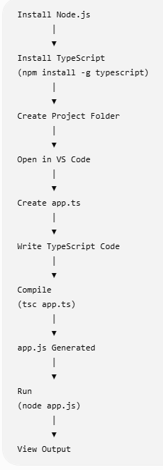

Task-13
Create a demo and see how generics work in ts.
function display<T>(value: T): T {
return value;
}
console.log(display<number>(100));
console.log(display<string>("Hello"));
console.log(display<boolean>(true));

Task 14: What are Type Annotations in TypeScript?
Type annotations are used to explicitly specify the data type of variables, function parameters, return values, and object properties. They help TypeScript detect type-related errors during compilation.

Task 15: What is the purpose of the any keyword in TypeScript?
The any type allows a variable to store any type of value. It disables TypeScript's type checking for that variable.
let value: any;
value = 100;
console.log(value);
value = "Hello";
console.log(value);
value = true;
console.log(value);

Task 16: Example showing the difference between any and unknown
Using any
let value: any = "TypeScript";

console.log(value.toUpperCase()); // Works

value = 100;
console.log(value.toFixed(2)); // Works
With any, TypeScript allows all operations without checking the type.

Using unknown
let value: unknown = "TypeScript";

if (typeof value === "string") {
console.log(value.toUpperCase());
}

value = 100;

if (typeof value === "number") {
console.log(value.toFixed(2));
}
Task 17: What is the tsconfig.json file used for?
The tsconfig.json file is the configuration file for a TypeScript project. It tells the TypeScript compiler (tsc) how to compile the project.

Home Tasks:of day 13

Task 1:
What are window functions in Postgresql?

Task 2:
What are the keywords that we use in window functions?
Keyword | Purpose
OVER() | Defines a window function. Mandatory.
PARTITION BY | Divides rows into groups.
ORDER BY | Specifies the order within each partition.
ROWS | Defines the physical window frame.
RANGE | Defines the logical window frame.
UNBOUNDED PRECEDING | Starts from the first row.
CURRENT ROW | Refers to the current row.
FOLLOWING | Includes rows after the current row.

Task 3: What are the types of Window Functions in PostgreSQL?
There are four main types.
1. Ranking Functions
Assign ranks to rows.
- ROW_NUMBER()
- RANK()
- DENSE_RANK()
- NTILE()
Example:
SELECT emp_name,
salary,
RANK() OVER(ORDER BY salary DESC)
FROM employee;

2. Aggregate Window Functions
Perform aggregate calculations without grouping.
- SUM()
- AVG()
- COUNT()
- MIN()
- MAX()
Example:
SELECT emp_name,
salary,
SUM(salary) OVER()
FROM employee;

3. Value Functions
Return values from another row.
- LAG()
- LEAD()
- FIRST_VALUE()
- LAST_VALUE()
- NTH_VALUE()
Example:
SELECT emp_name,
salary,
LAG(salary) OVER(ORDER BY salary)
FROM employee;

4. Distribution Functions
Used for statistical analysis.
- CUME_DIST()
- PERCENT_RANK()
Example:
SELECT emp_name,
salary,
PERCENT_RANK() OVER(ORDER BY salary)
FROM employee;

Task 4:
What are the rules while working on window functions?
• Every window function must contain the OVER() clause.
• Window functions are executed after the WHERE, GROUP BY, and HAVING clauses.
• They can be used only in:
- SELECT
- ORDER BY
• They cannot be used directly in:
- WHERE
- GROUP BY
- HAVING
• PARTITION BY is optional.
• ORDER BY is optional for some window functions but required for ranking functions like RANK() and ROW_NUMBER().
• Window functions do not reduce the number of rows.

Task 5:
Do we have JSON/JSONB data types in postgresql ? What is the diff between them?
JSON | JSONB
Stored as text | Stored in binary
Slower queries | Faster queries
Preserves formatting | Does not preserve formatting
No indexing | Supports indexing
Faster insert | Slightly slower insert
Larger storage | More compact storage

Task 6:
What is full text search in postgresql? Explain briefly?
Full Text Search (FTS) is a feature in PostgreSQL used to search large amounts of text efficiently.
Instead of searching exact words using LIKE, Full Text Search:
- breaks text into words (tokens),
- removes common words (stop words),
- supports word stemming (e.g., "running" → "run"),
- provides fast searching using indexes.

Task 7:
What do you understand by full text search in postgresql?
Full Text Search is an advanced text-search mechanism that enables searching documents, articles, comments, or product descriptions quickly and accurately.
It uses:
- to_tsvector() – Converts text into searchable tokens.
- to_tsquery() – Converts a search string into a query.
- @@ – Matches the search query with the text vector.

Task 8:
What does savepoint do in postgres?
A SAVEPOINT creates a checkpoint inside a transaction. If an error occurs, you can roll back to that savepoint instead of rolling back the entire transaction.

